**UNWILLING MARKET INSIGHTS: ANALYZING SPENDING BEHAVIOUR AND IDENTIFYING OPERTUNITIES FOR GROWTH**

**1.INTRODUCTION**

1.1 Overview

Unwilling market insights involves analyzing and revealing key information about a market including trends, consumer behavior, competition, and opportunities. It encompasses market research, data analysis, and strategic interpretation to aid businesses in making informed decisions and developing effective marketing strategies.

1.2 Purpose

1. Make informed decision

2.Identify opportunities

3.Mitigate risks

**2.Problem Definition & Design Thinking**

2.1 Empathy map

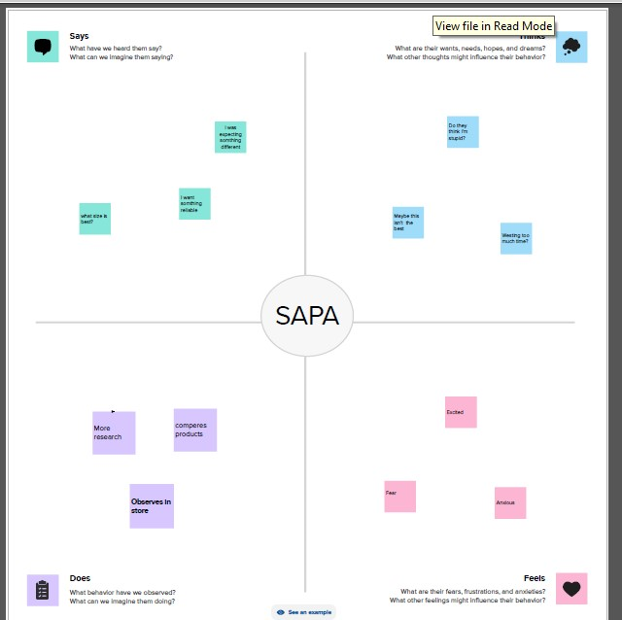

2.2 Ideation & Brainstorming map

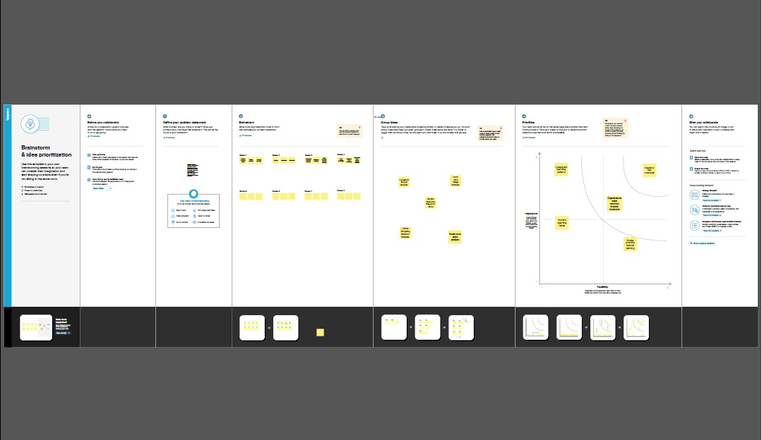

**3.RESULT**

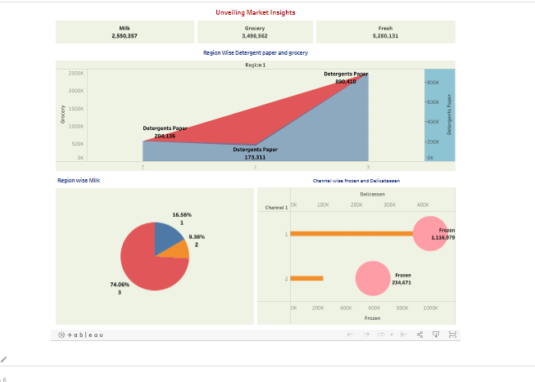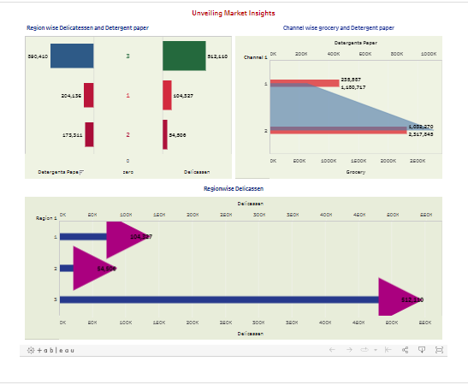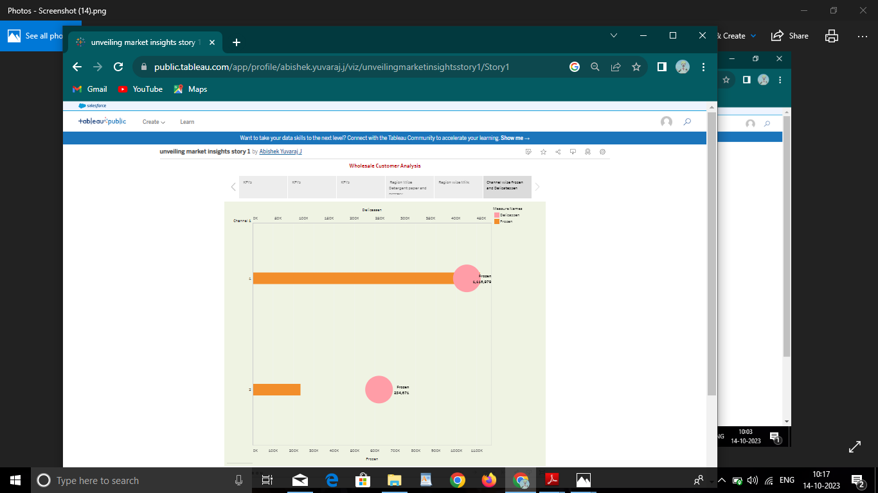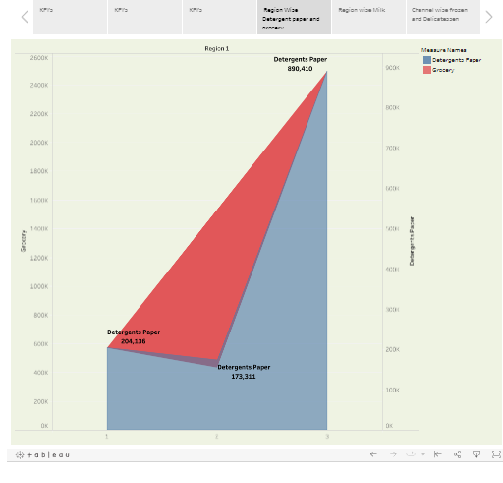

**4.ADVANTAGES & DISADVANTAGES**

1. Advantages:

1. Informed decision making
2. Competitive edge
3. Customized marketing strategies
4. Marketing entry expansion

Disadvantages:

1. Cost and resource intensiveness

2. Data accuracy and reliability

3.Overreliance on data

Application:

1.Prodect development and innovation

2.Marketing strategy and campaigns

Conclusion:

In conclusion, unveiling market insights is a fundamental practice for businesses seeking to navigate the complex and dynamic landscapes of modern markets.